Installing Jenkins with Docker

Firstly we create a container in our machine. We need docker installed and running in our machines. Execute this command:

docker run -d -p 8080:8080 jenkins/Jenkins

We can access our jenkins in http://localhost:8080/ (for ec2 instance IPv4 Public IP:8080). We will see the screen below. Put the admin password in input on the screen and press continue.

**⚠️Note:**

* To access the admin password:
* If you run Jenkins inside docker as a detached container, you can use **docker logs containerId**commands to view the Jenkins logs.
* Or, execute the following commands:  
  **$ docker exec -it containerId bash**  
  **$ cat /var/jenkins_home/secrets/initialAdminPassword**

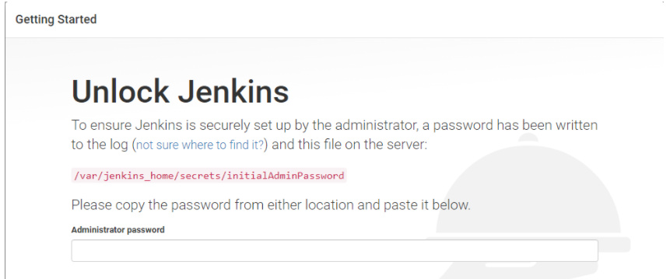



Jenkin is ready!